import java.io.*;

import java.util.*;

public class Leaky

{

public static void main(String args[]) throws Exception

{

Queue q=new Queue();

Scanner src=new Scanner(System.in);

System.out.println("\nEnter the packets to be sent:");

int size=src.nextInt();

q.insert(size);

q.delete();

}

}

class Queue

{

int q[],f=0,r=0,size;

void insert(int n)

{

Scanner in = new Scanner(System.in);

q=new int[10];

for(int i=0;i<n;i++)

{

System.out.print("\nEnter " + i + " element: ");

int ele=in.nextInt();

if(r+1>10)

{

System.out.println("\nQueue is full \nLost Packet: "+ele);

break;

}

else

{

r++;

q[i]=ele;

}

}

}

void delete()

{

Scanner in = new Scanner(System.in);

Thread t=new Thread();

if(r==0)

System.out.print("\nQueue empty ");

else

{

for(int i=f;i<r;i++)

{

try

{

t.sleep(1000);

}

catch(Exception e){}

System.out.print("\nLeaked Packet: "+q[i]);

f++;

}

}

System.out.println();

}

}

**Output:**

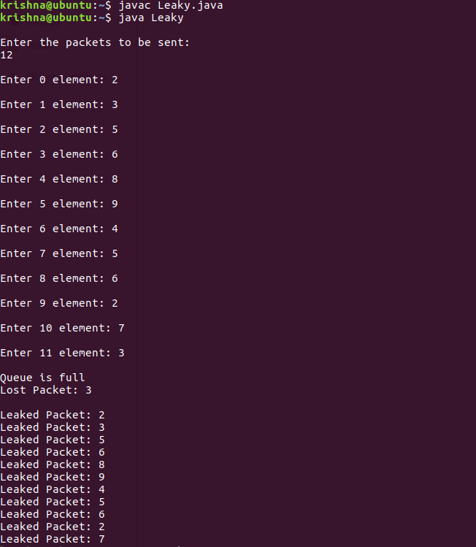

import java.util.*;

public class leaky_b

{

public static void main(String[] args)

{

Scanner my = new Scanner(System.*in);*

int no_groups,bucket_size;

System.*out.print("\n Enter the bucket size : \t");*

bucket_size = my.nextInt();

System.*out.print("\n Enter the no of groups : \t");*

no_groups = my.nextInt();

int no_packets[] = new int[no_groups];

int in_bw[] = new int[no_groups];

int out_bw,reqd_bw=0,tot_packets=0;

for(int i=0;i<no_groups;i++)

{

System.*out.print("\n Enter the no of packets for group " + (i+1) + "\t");*

no_packets[i] = my.nextInt();

System.*out.print("\n Enter the input bandwidth for the group " + (i+1) + "\t");*

in_bw[i] = my.nextInt();

if((tot_packets+no_packets[i])<=bucket_size)

{

tot_packets += no_packets[i];

}

else

{

do

{

System.*out.println(" Bucket Overflow ");*

System.*out.println(" Enter value less than " + (bucket_size-tot_packets));*

no_packets[i] = my.nextInt();

}

while((tot_packets+no_packets[i])>bucket_size);

tot_packets += no_packets[i];

}

reqd_bw += (no_packets[i]*in_bw[i]);

}

System.*out.println("\nThe total required bandwidth is " + reqd_bw);*

System.*out.println("Enter the output bandwidth ");*

out_bw = my.nextInt();

int temp=reqd_bw;

int rem_pkts = tot_packets;

if((out_bw<=temp)&&(rem_pkts>0))

{

System.*out.println("Data Sent \n");*

--rem_pkts;

System.*out.println("Remaining Bandwidth " + (temp -= out_bw));*

if (temp==0)

{

System.*out.println("All packets are sent");*

}

}

if(rem_pkts>0)

System.*out.println(" packets discarded due to insufficient bandwidth");*

}

}